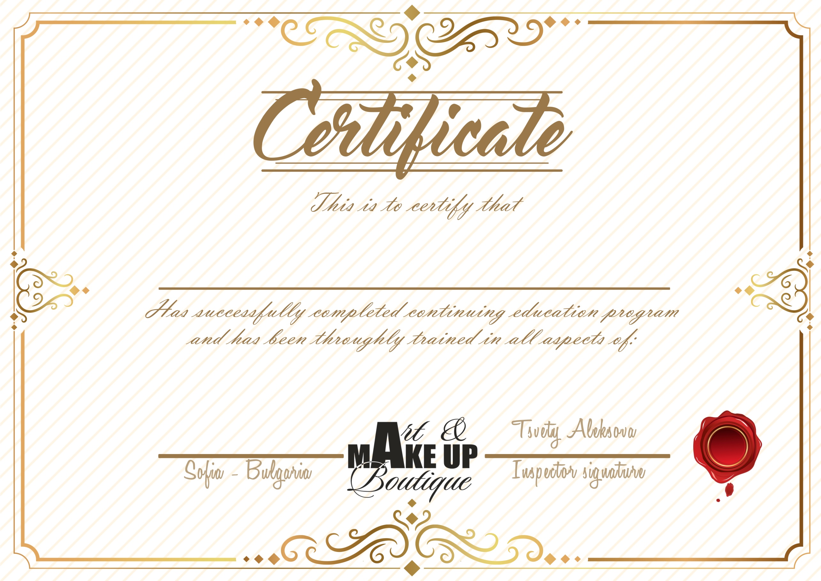

**01.11.2016**

**Beauty Make-up Course**

**Анелия Димитрова**